**Project: Variant Calling in Drosophila using NGS Data Analysis**

*Project Description:*

* Attempted to perform NGS data analysis for variant calling on a random sample of Drosophila using publicly available datasets
* Performed quality control, alignment, and variant calling to identify and annotate genetic variations
* Aimed to gain hands-on experience with NGS data analysis techniques and tools for variant calling

**The fundamental workflow pipeline that I adhered to in this project was as follows:**

**Step:1** Set up the environment for the analysis by installing the necessary tools and software

**Step:2** Download the FASTQ files from the NCBI Sequence Read Archive (SRA) Toolkit.

**Step:3** Perform quality control of NGS reads using FASTQC and MultiQC.

**Step:4** Trim the sequences to remove low-quality bases and adapters.

**Step:5** Index the reference genome to prepare it for alignment.

**Step:6** Align the reads to the reference genome using a tool like BWA or Bowtie.

**Step:7** Convert the alignment file from SAM to BAM format.

**Step:8** Mark duplicate reads using a tool like Picard.

**Step:9** Perform variant calling using a tool like GATK or Samtools.

**Step:10** Filter the variants to remove low-quality and false-positive calls.

**Step:11** Annotate the variants with information about their functional effects and population frequencies.

**Procedure:**

***Steps to Set Environment and downloading FASTQ Files***

export PATH="/home/ruchika/class/software/sratoolkit.2.11.2-ubuntu64/bin:$PATH"

sudo apt install fastqc

python3-pip

sudo apt install python3-pip

pip install multiqc wget https://repo.anaconda.com/miniconda/Miniconda3-latest-Linux-x86_64.sh conda install -c bioconda fastp



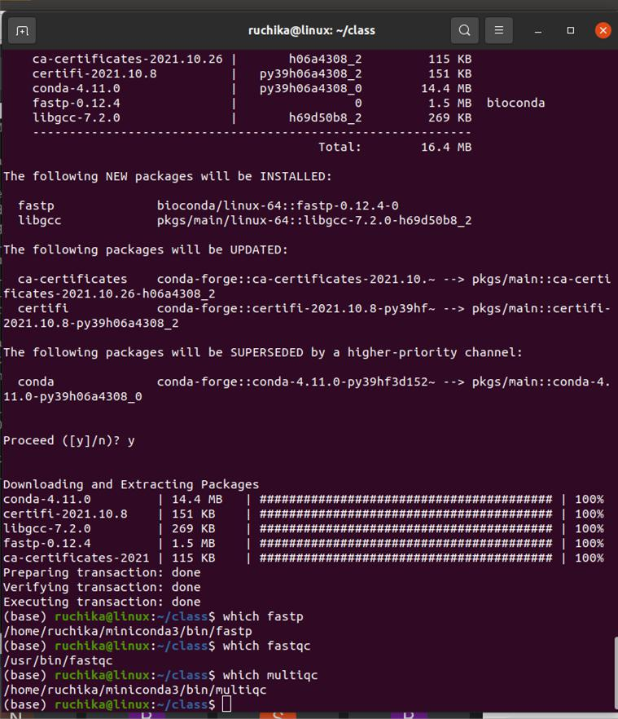

wget https://repo.anaconda.com/miniconda/Miniconda3-latest-Linux-x86_64.sh bash Miniconda3-latest-Linux-x86_64.sh

conda install -c bioconda -c conda-forge multiqc conda install -c bioconda fastp

**Download the FASTQ files from the NCBI Sequence Read Archive (SRA) Toolkit**

wget http://ftp-trace.ncbi.nlm.nih.gov/sra/sdk/current/sratoolkit.current-ubuntu64.tar.gz



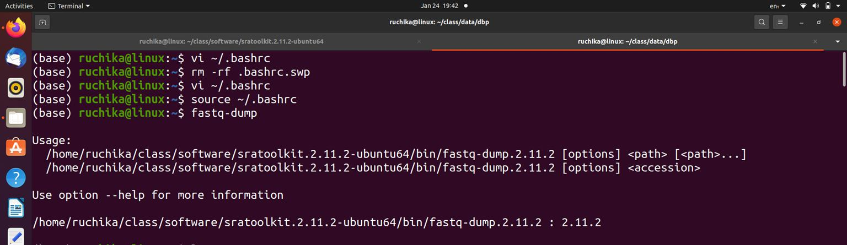

tar -vxzf sratoolkit.tar.gz

vdb-config –interactive

fastq-dump --split-3 SRR12991870 SRR12991871 --outdir COVID19_IGIB fastq dump --split-3 SRR12991870 --outdir dbp

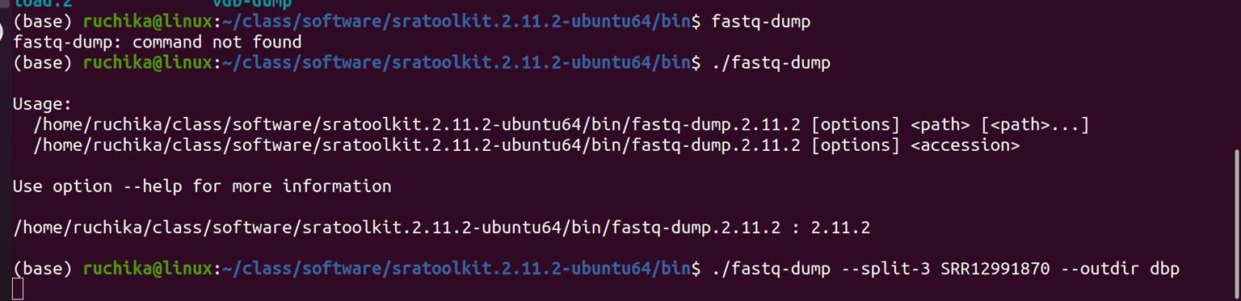

/home/ruchika/class/software/sratoolkit.2.11.2-ubuntu64/bin

export PATH="/home/ruchika/class/software/sratoolkit.2.11.2-ubuntu64/bin:$PATH"

fastqc SRR12991870_1.fastq SRR12991870_2.fastq

**fastp -i SRR12991870_1.fastq -o SRR12991870_R1.fastq -I SRR12991870_2.fastq -O SRR12991870_R2.fastq**

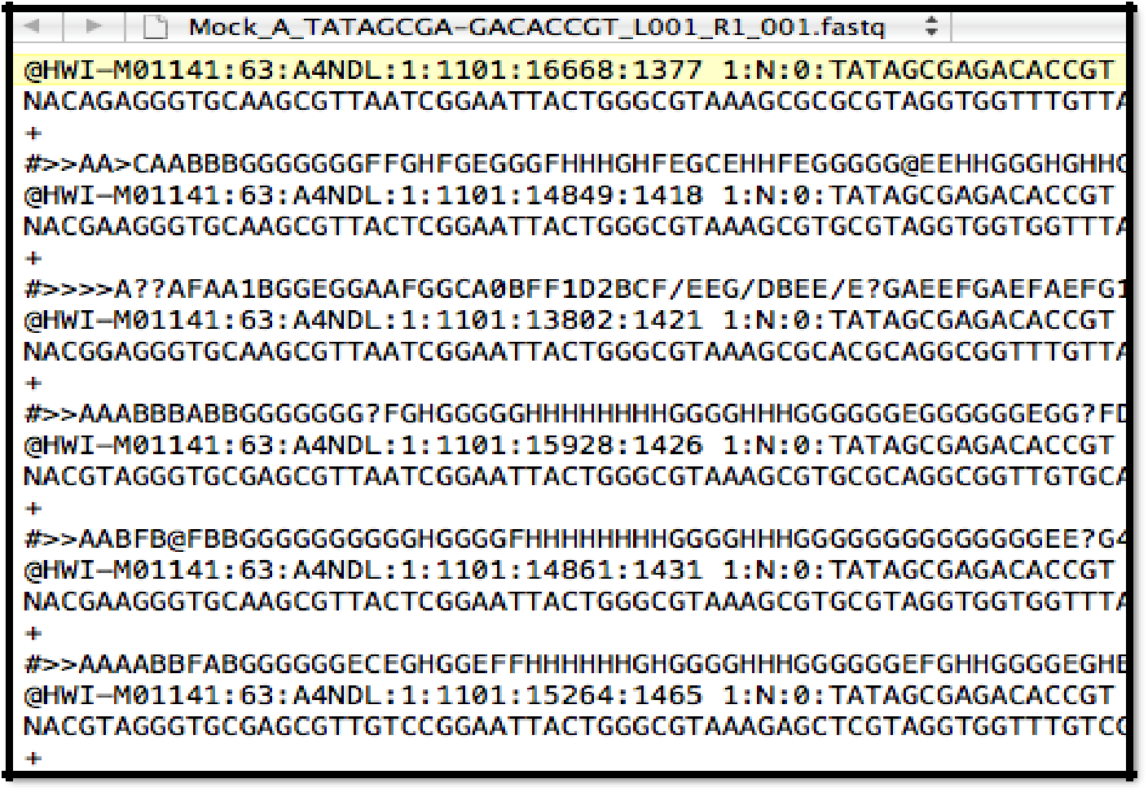

Perform quality control of NGS reads using FASTQC and MultiQC

**Command to perform:** fastqc SRR12991870_1.fastq SRR12991870_2.fastq

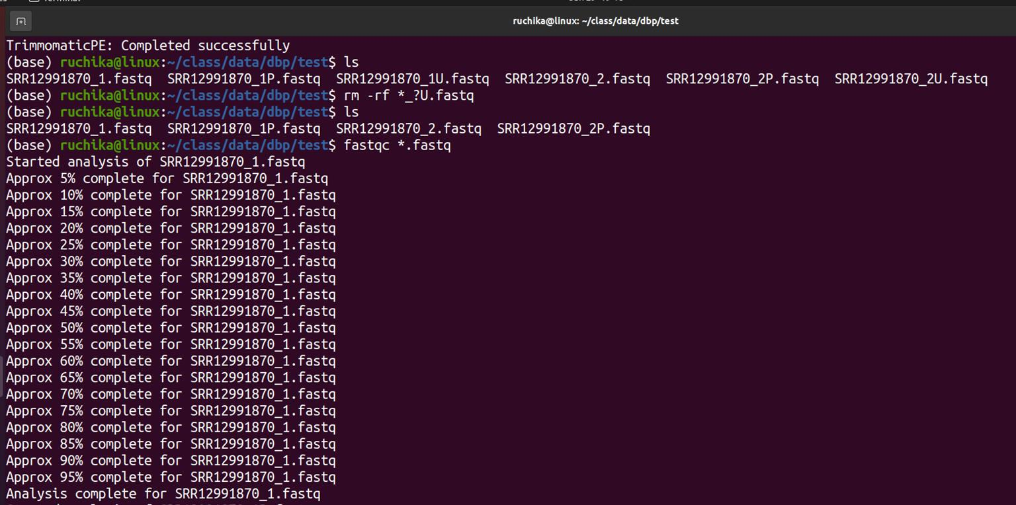

**Outcome**

(base) ruchika@linux:~/class/data/dbp$ ls

SRR12991870_1.fastq SRR12991870_1_fastqc.html SRR12991870_1_fastqc.zip SRR12991870_2.fastq SRR12991870_2_fastqc.html SRR12991870_2_fastqc.zip



**MultiQC**

**Command:** multiqc . –p

**Outcome**: multiqc_data multiqc_plots multiqc_report.html SRR12991870_1.fastqSRR12991870_1_fastqc.html SRR12991870_1_fastqc.zip SRR12991870_2.fastq SRR12991870_2_fastqc.html SRR12991870_2_fastqc.zip

**Fastp Command:** fastp -i SRR12991870_1.fastq -o SRR12991870_R1.fastq -ISRR12991870_2.fastq -O SRR12991870_R2.fastq

**Trim the sequences to remove low-quality bases and adapters**

**Command** - java -jar /mnt/san3-aiims/software/Trimmomatic-0.39/trimmomatic-0.39.jar PE -

phred33 -threads 4 SRR12991870_1.fastq SRR12991870_2.fastq -baseout

SRR12991870.fastq ILLUMINACLIP:/mnt/san3-aiims/software/Trimmomatic-0.39/adapters/all.fa:2:30:10 LEADING:20 TRAILING:20 SLIDINGWINDOW:4:15 MINLEN:35

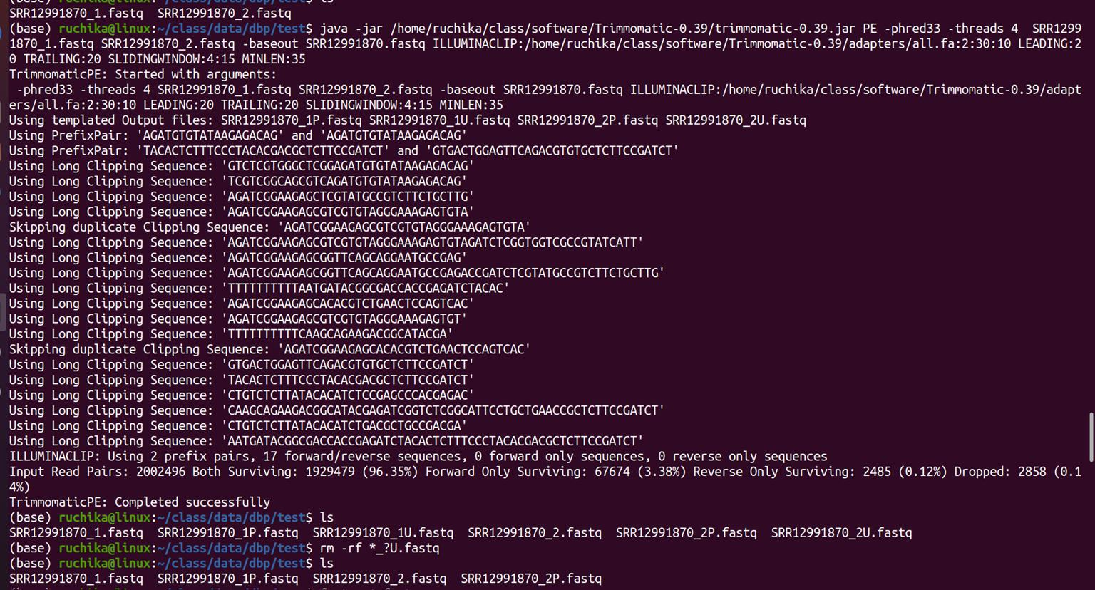

**Result**

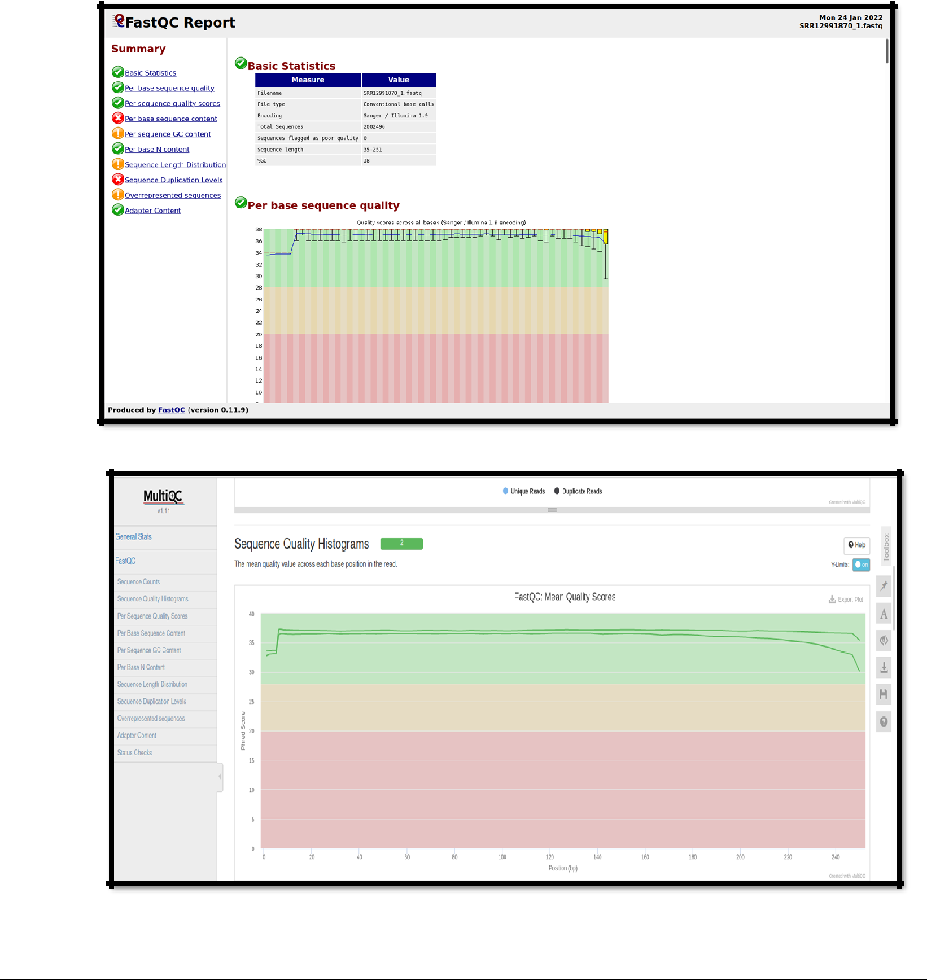

**Steps to Perform Variant Calling:**

Wget

https://ftp.ncbi.nlm.nih.gov/genomes/all/GCF/009/858/895/GCF_009858895.2_ASM985889 v3/GCF_009858895.2_ASM985889v3_genomic.fna.gz

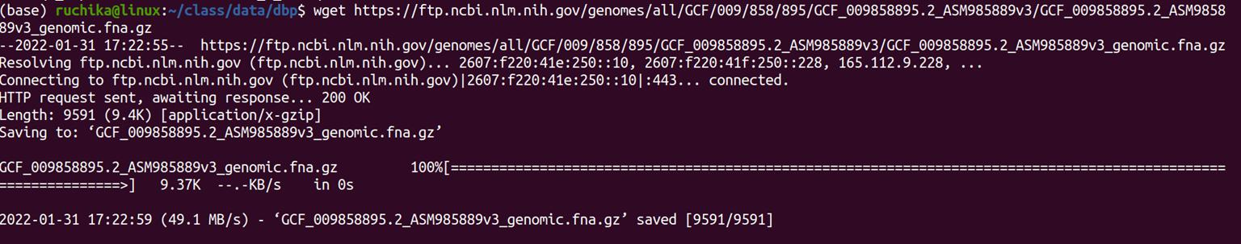

gunzip *.gz

mv GCF_009858895.2_ASM985889v3_genomic.fna NC_045512.2.fasta home/ruchika/class/data/dbp/test/gatk-4.2.2.0

gatk CreateSequenceDictionary -R NC_045512.2.fasta -O NC_045512.2.dict

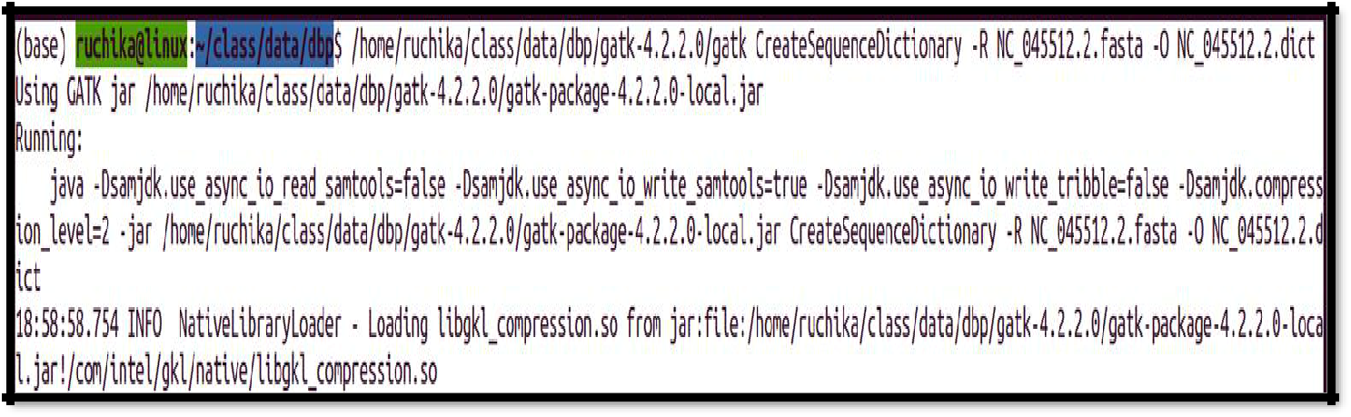

bwa mem -t 8 NC_045512.2.fasta SRR12991870_R1.fastq SRR12991870_R2.fastq -o SRR12991870.sam

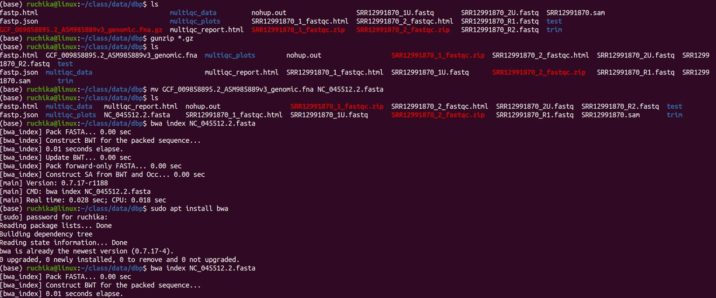

gatk SortSam --INPUT SRR12991870.sam --OUTPUT SRR12991870.bam --SORT_ORDER coordinate

gatk BuildBamIndex --INPUT SRR12991870.bam

gatk CollectAlignmentSummaryMetrics --REFERENCE_SEQUENCE NC_045512.2.fasta --

INPUT SRR12991870.bam --OUTPUT SRR12991870_alignment_metrics.txt --

VALIDATION_STRINGENCY LENIENT

conda install -c bioconda deeptools

plotCoverage --bamfiles SRR12991870.bam --outRawCounts SRR12991870.tab -o SRR12991870.png

gatk CollectInsertSizeMetrics --INPUT SRR12991870.bam --OUTPUT SRR12991870_metrics.txt --Histogram_FILE SRR12991870_bwa_histogram.pdf

sudo apt install r-base

gatk AddOrReplaceReadGroups --INPUT SRR12991870.bam --OUTPUT SRR12991870_group.bam --RGLB lib1 --RGPL illumina --RGPU NONE --RGSM SRR12991870

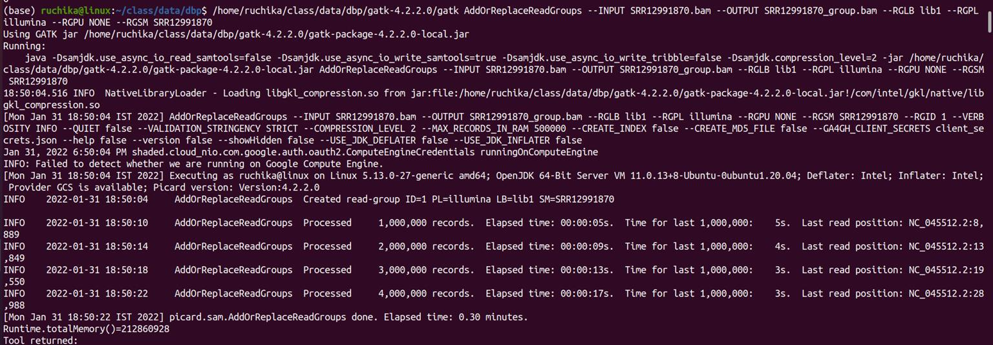

**Mark Duplicate Reads**

gatk MarkDuplicates --INPUT SRR12991870_group.bam --OUTPUT SRR12991870_dedup_reads.bam --METRICS_FILE SRR12991870_metrics.txt -AS true -- VALIDATION_STRINGENCY LENIENT

gatk BuildBamIndex --INPUT SRR12991870_dedup_reads.bam

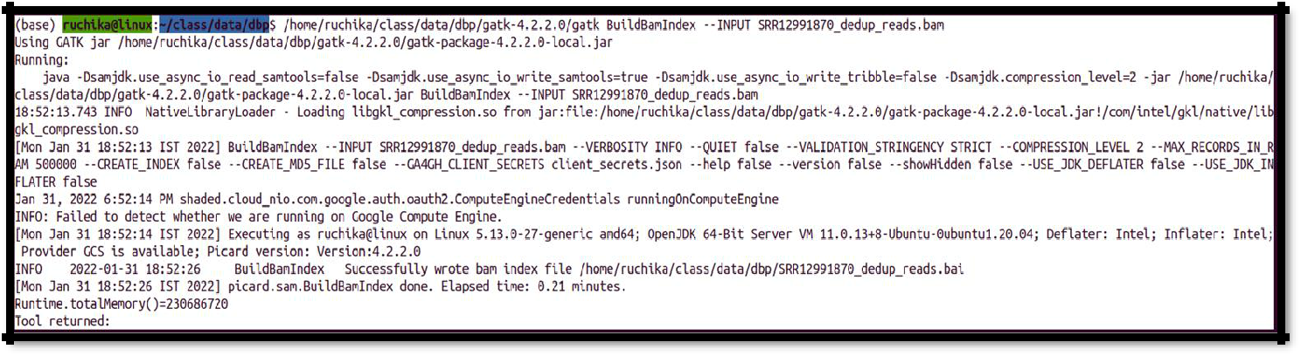

gatk HaplotypeCaller -R NC_045512.2.fasta -I SRR12991870_dedup_reads.bam -ploidy 1 -O SRR12991870.vcf

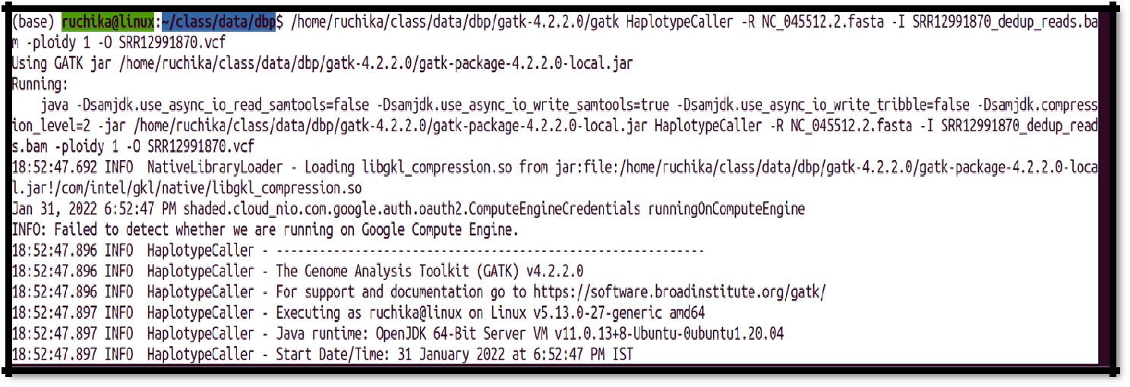

/home/ruchika/class/data/dbp/gatk-4.2.2.0/gatk SortSam --INPUT SRR12991870.sam -- OUTPUT SRR12991870.bam --SORT_ORDER coordinate

/home/ruchika/class/data/dbp/gatk-4.2.2.0/gatk CreateSequenceDictionary -R NC_045512.2.fasta -O NC_045512.2.dict

wget https://snpeff.blob.core.windows.net/versions/snpEff_latest_core.zip

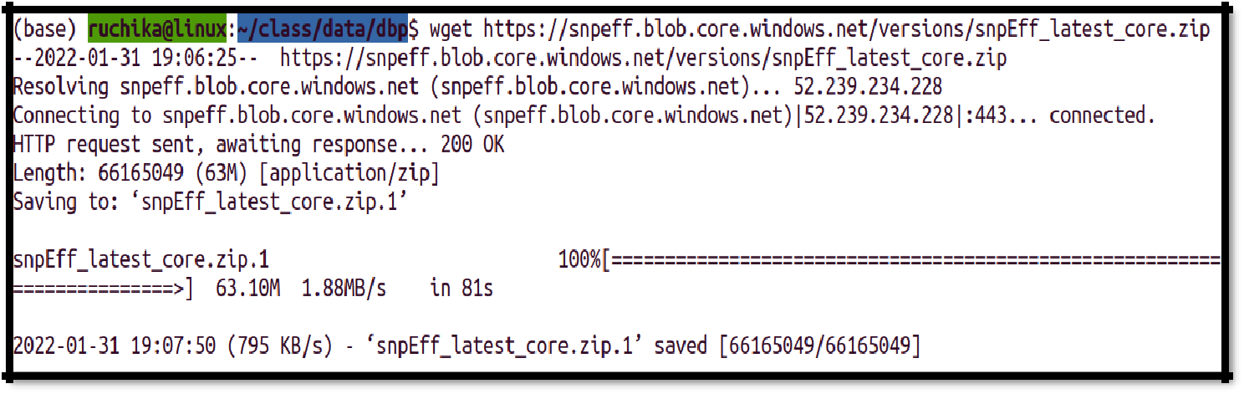

java -jar snpEff.jar databases | grep "NC_045512.2"

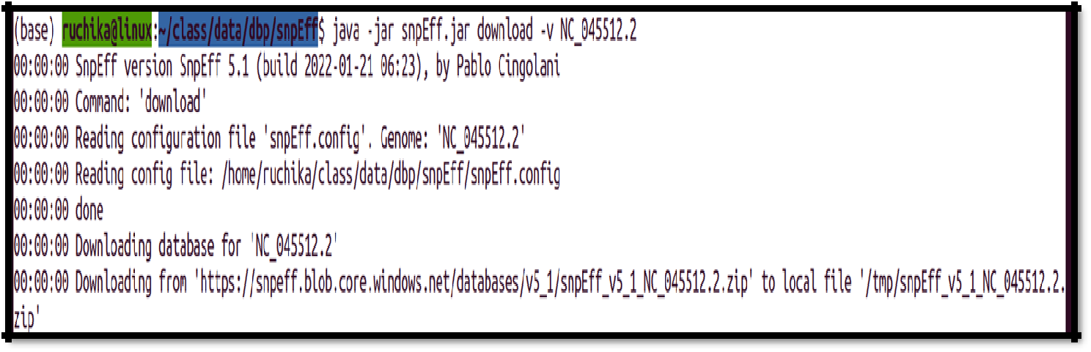

**VCF Format:**

java -jar snpEff.jar download -v NC_045512.2

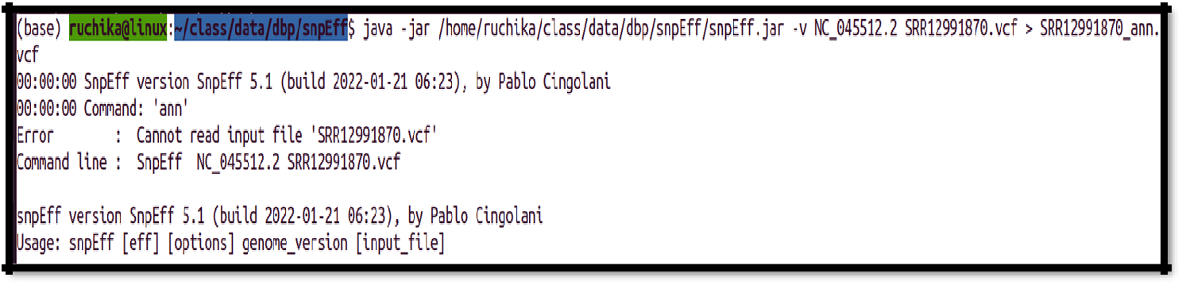

**Result**

The end goal of these sequencing is for accurate variant identification and interpretation that could help in clinical diagnoses.

